

EasyWash.ERP Laundry and Dry-cleaning Solutions

What is EasyWash.ERP?
EasyWash.ERP is an Enterprise Resource Software developed to manage Laundry and Dry-cleaning services. An Enterprise Resource Planning (ERP) Application is a business management software that allows an organization to use a system of integrated applications to manage theERP System integrate external and internal management of information across an entire organization and embracing finance/accounting, manufacturing, sales and services, customer relationship management,. It automates these activities with an integrated software application.

EasyWash.ERP is modular Application software that can run on the web browsers and make transactions on the internet.
EasyWash.ERP modules are:
- Customer Service/Customer Relationship Management (CRM)
- Accounting / Admin / Human Resources
- Operations / Garment Analysis
- Customer’s Portal
THE CUSTOMER SERVICE / CRM MODULE
This module escalates the Customer Relationship Management and Services. In this module, your major activities are to record garment brought by customers, print invoice, do pick up and issue receipts, check customer’s ledger or transaction history, daily invoice reports with several options, re-print invoice and tag, register new customer with the necessary parameters etc.

TABLE OF CONTENTS FOR CS/CRM
- User Login
- Welcome page/Home page for Customer Service department
- New Customer Registration form
- New item registration form
- Searching for Customer Records
- Invoice Generation
- Pickup/Issue of Receipt
- Reports: Regular Customer, Staff Customers, Package Customers, Complementary Customers
- Invoice Status
- All Incoming Invoices
- Package Customers
- New Package Order
- Generating invoice for package customer
- Customer Relationship Management (CRM)
- Extra Charge
- Void/Delete invoice
- Void Receipt
- Express Invoice
- Redo/No charge
- Invoice Preference
- Bar Coding System
- Permanent Discount Setup for loyalty customers
- Closed and Unclosed invoices
User Login
This is the area where a user enters his or her username and password.
To login to your department, launch the application with your domain name e.g.www.easywasherp.com.

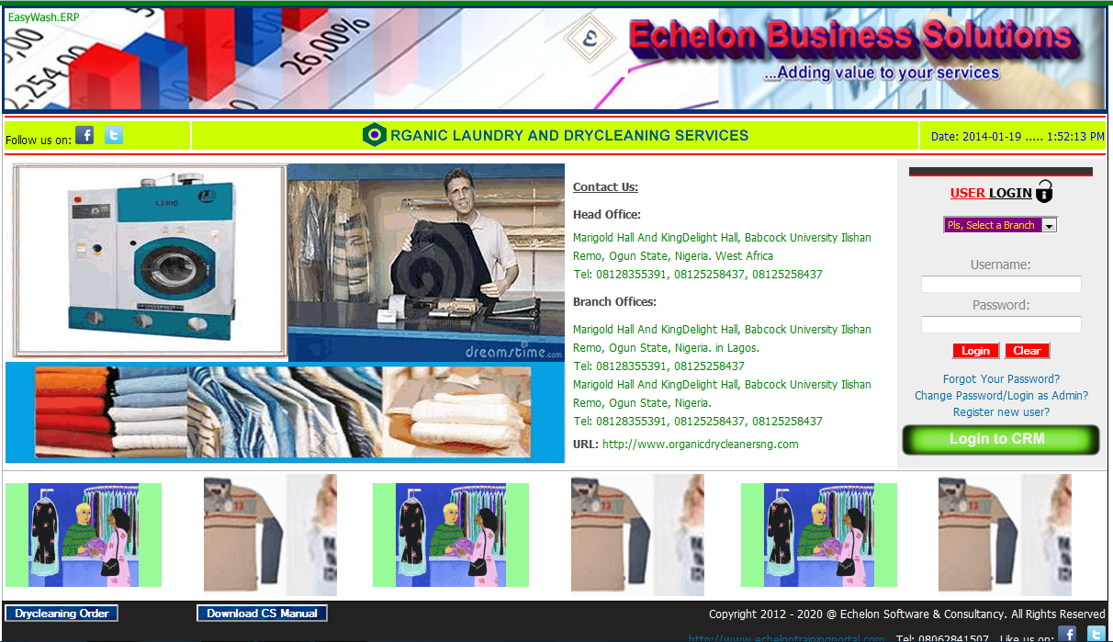

In the home page select a branch where you are working e.g.selecting another branch where you don’t work will still login for customer service department but you will not be able to view transaction histories of your branch. If you don’t select your branch you will not see your records and invoices that you have generated.

After selecting your branch, enter your username and password, click on login button. If login successful, a customer service module/page will be launched.
Customer Service Department/CRM
Customer service department and customer relationship management is a page/module where you attend to your customers and view several reports relating to customer transaction histories, sales or invoice reports on daily, weekly, monthly, quarterly and annual basis.
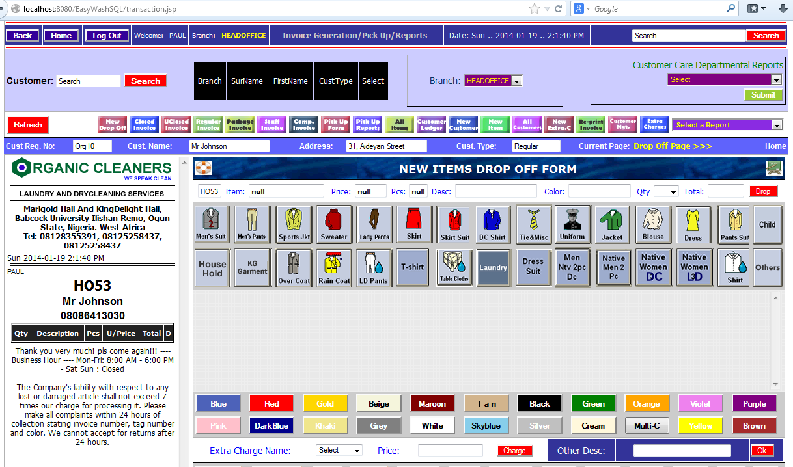

Customer Service page will display the name of the user and the branch where you are operating from at a particular session. Always endeavor to logout after all transactions for security purpose.

Customer Service module has menus that you can use to view report and short cut button to make your activities faster.

New Customer Registration
Before you can generate an invoice for a customer, the customer must be registered into the system.
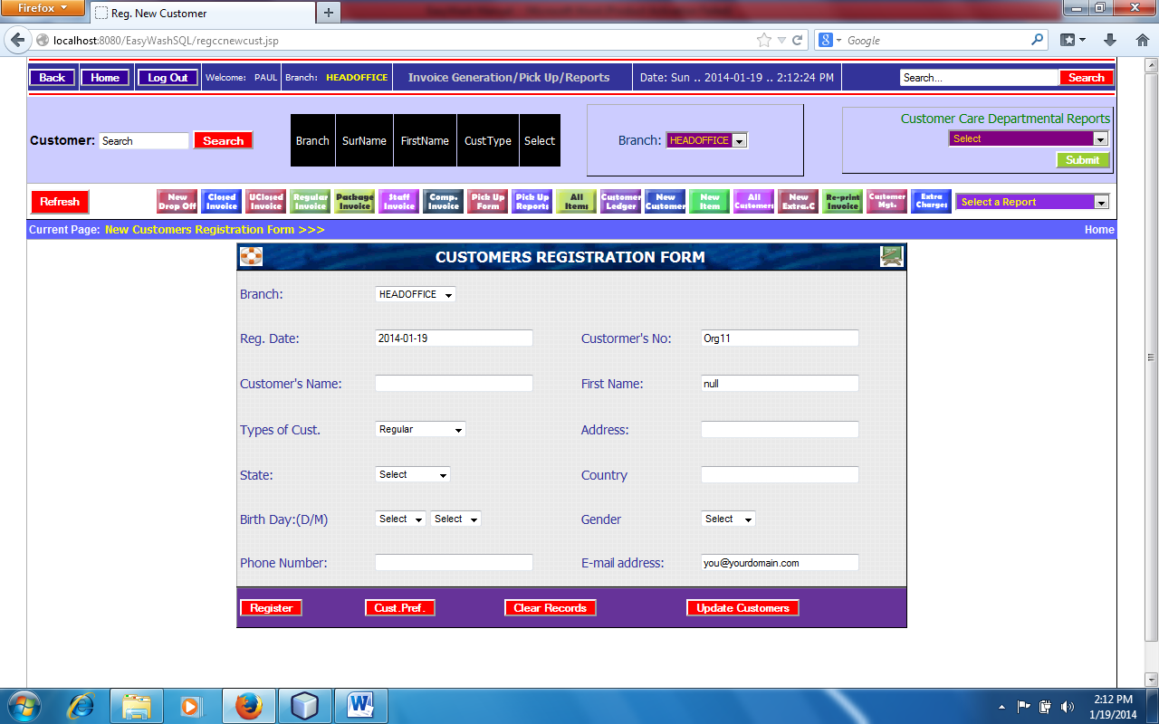
- Click on New Customer from the short cut buttons
- Date customer’s registration numbers and branch are automatic
- Enter the Surname and Firstname of the customer i.e. othername is not compulsory
- Enter Address, State and country
- Select customers type e.g. Regular, Package, Complementary and Staff.
N.B. Regular customers are normal customers that brought garment and pay with or no discount.
Package Customersare special customers that pay upfront for a particular number of items.
Complementary Customers are the type of customer that does not pay any money after generating invoice. This type of customer is Pastor, Imam, Land Lord and any special person including charity home or organization.
Staff Customers: These are workers in the laundry company which can also dry-clean garments without payment. The company’s management may give each staff number of items to dry-clean per month.
- After selecting customer type, select birth day i.e. 12/07 which means the person was born on the 12th of July of any year. Therefore, year is not compulsory as birthday is celebrated every year. You must select the birthday in order to use Customer Relationship Management (CRM) facilities.
- Enter email address if available but not compulsory
- Phone number is compulsory
- Click on register button to register the customer
Note: You can change/update customer’s information after registration.

To view all your customers
- Click on All Customers from the short cut buttons. It will display 25 records per page
- Click on the next page to view other customers

How to register new Item
Items are the garments/Cloths that you dry-clean. Some items have two or more pieces but one quantity. For instance, Buba/Sokoto/Agbada are regarded as one item quantity which must be priced together but have three pieces. Likewise some suits have two or more pieces etc.
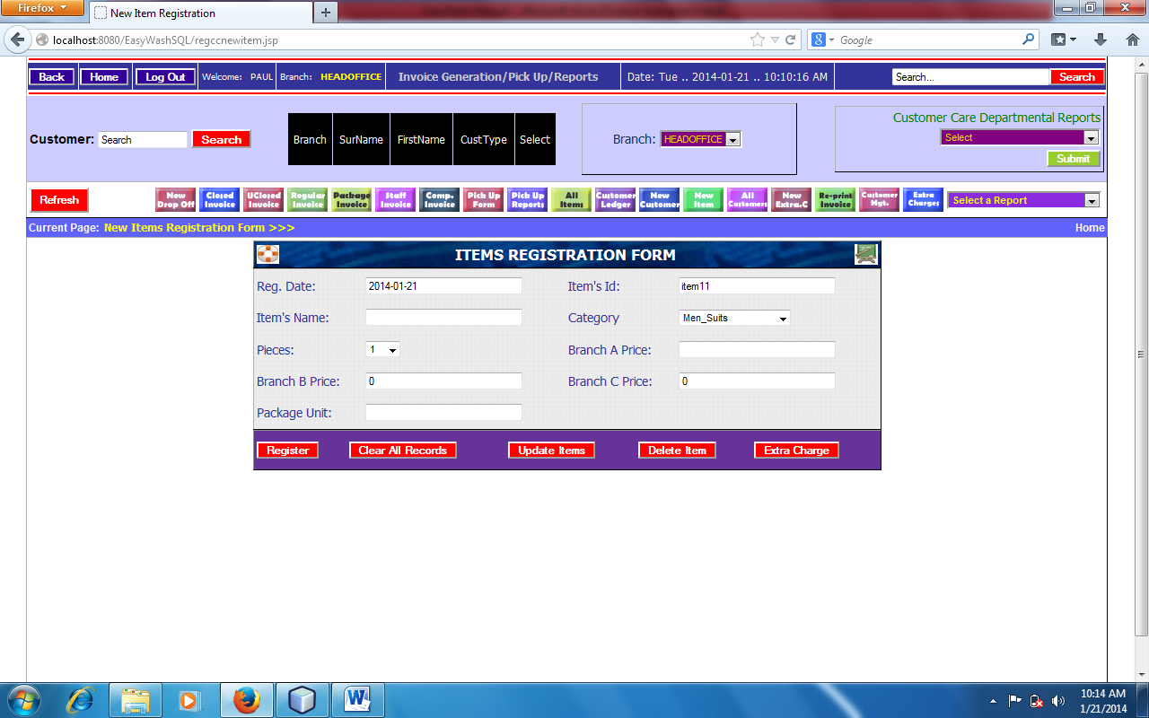

- Click on New Item from the short cut buttons
- Date, Branch and Itemid are automatic
- Enter item Name e.g. Men Suit 2PC or Shirt
- Select number of pieces of the item
- Select category from the list, select other category special not common items
- Type price for Head Office (Branch A), Branch B and C for other branches
Note: If you have only Head Office, type price for Head Office and leave others for 0 entries.
- For Package Unit, enter number of pieces as the package unit unless you want any modification.
- Click on Register button.

To view all registered items
- Click on All Items from the short cut button

Searching for customer’s information before generating invoice
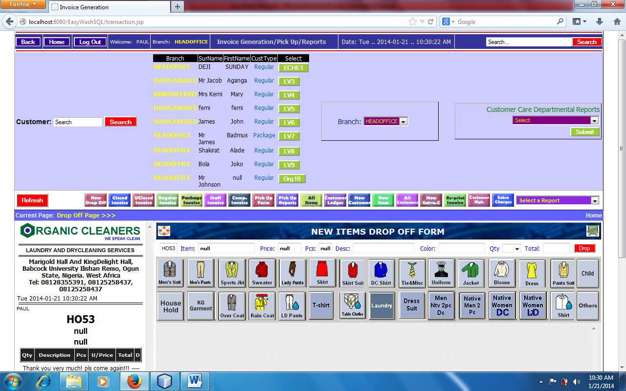

The application provides searching algorithm to help locate customer’s information before invoice is generated for a particular customer. For the best result, always use the initial of the surname or firstname or you can use the first two letters. Do not type the full name because is not necessary.
At the left top of the customer service module, you will see a textfield called search, type the initial of the surname or firstname and click on search button or press enter key from the keyboard. A search results will be displayed beside the search button displaying customer information as shown in the diagram above. The information comprises Customer’s name, Customer type e.g. Regular, Package, Complementary and Staff.

A customer can have two accounts on the system with the same name but different registration number. He/She can have both regular and package account on the system. In the searched result, it will display two accounts information for a particular customer; choose the type of invoice that you want to generate whether regular or package and click on customer registration number.

Invoice Generation
Invoice generation is when customersbring items and register them on the system for laundry and dry-cleaning purposes. A final result of the transaction called invoice will be printed and give customer a copy for record purpose.

There are three phases in generating invoice:
- Customer information
- Item Registration / Drop off
- Deposit and Conclusion

Phase one: Customer Information:
If a customer is an existing customer, search for the customer. See searching for customer information for details. If is a new customer, quickly register the customer by using registration form and search for the customer.
After selecting the customer of your choice, the name and phone number of the customer will be displayed in invoice preview at the left side of the customer service page. See the diagram below:
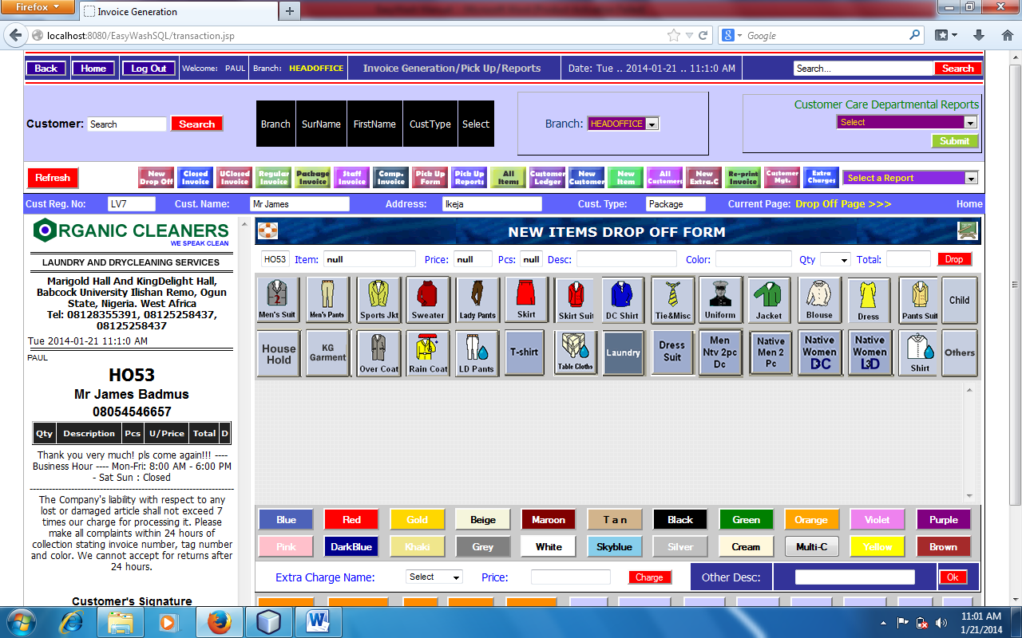

Phase two: Items Drop Off:
At the center of the page, you will see icons representing each item category as shown in the diagram above.
- Click on the item icon, you will see all the items registered under the clicked category with green color.
- Select the item of your choice
- At the top of the item icon button, the system will display the name of the item, the pieces and the price as registered during items registration. You will not be able to modify price! Only administrator will be able to change price.
- Enter item description if necessary like Loose button, Iron or ink stain, color run etc
- Select color from the color buttons or type any color of your choice
- Select item’s quantity
- Click on drop
- Repeat the above steps for other items.
Note: If you make mistake during item registration, click on “D” from item table at the left side of the page and delete the item. You may want to re-register the item.

Phase Three: invoice Conclusion:
- After you have registered all items brought by a customer
- Go to bottom side of the page and click on collection date (C. Date). By default it is 2 days interval. You can modify collection date.
- I.P. means Invoice Preference: you may want to pass information across that will display boldly on the invoice like little Starch, Press Only, Folded etc. but must be a very short description.
- Enter collection day. If showing undefined, endeavor to erase it and type collection day e.g Mon, Tue, Wed, Thur, Fri, Sat. Just three letters word.
- Total pieces is automatic
- Type discount if you want to give customer a discount
- Grand total is automatic and cannot be changed or modified.
- If customer wants to deposit any money, type the amount in the textfield provided
- Click on post button to post the transaction.
A confirmation page will be displayed asking you if you are sure of the invoice you are posting. You cannot modify or delete invoice after posting but Admin can void an invoice and it will be moved to archive database.
- Print your invoice as well as tags if you have a tag printer. Some people are using manual tagging system which does not affect the operation of the software.

The diagram below shows the preview of the final invoice and tags for the items
Click on print button to print invoice and tag.
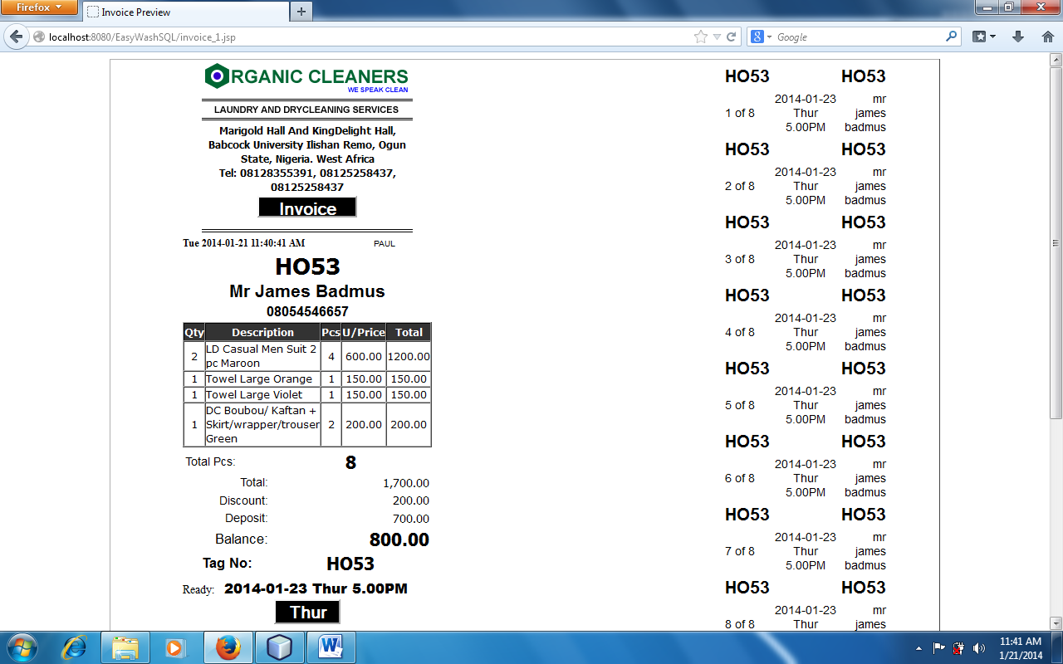

Pick up/ Issue of receipt
Pickup/issue of receipt is when customer wants to make part payment and collect his or her items. At times, a customer may want to make part payment without collecting any item. This gives rooms for subsequent payment. Customer can pay for the item several times until the invoice has zero balance. If the customer has paid all the money during drop off, there is no need to do pick up before collecting the items as he has no any balance to pay. Pick up and issue of receipt is majorly meant for subsequent payment and collection of items. If all bills have already been paid, just confirm the payment by clicking on Invoice Status from the Select menu and type the invoice number. Give all the items to the owner if payment is confirmed.
To pick up an item or issue receipt:
- Click on pick up form from the short cut buttons
- Type the invoice number from the textfield. Note: If no information displayed or displaying invoice has already been pick up or has been paid in full or does not exist. This means the invoice is not available for pick up. Check if the invoice number is typed correctly. Avoid using o for 0 means o letter for zero number. Invoice number is not case sensitive but for better result, you can use cap letter.
- Click on search button. This will display the invoice summary
- Click on Go to Pick up form. This will display the pick up form as shown below

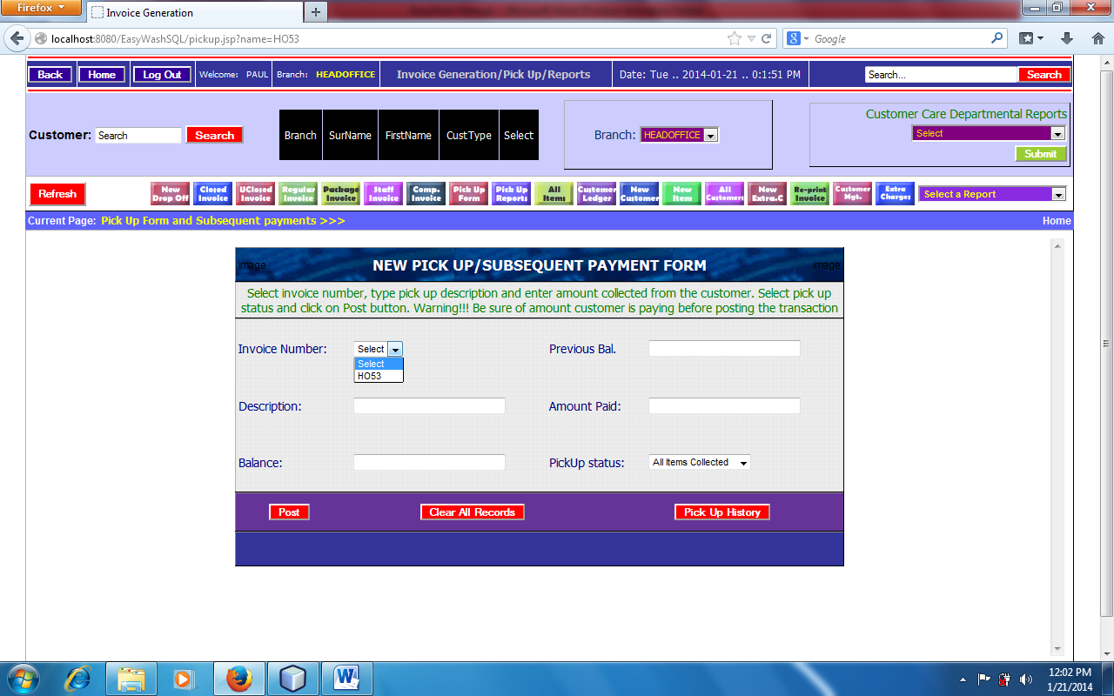

- Select invoice number. This will automatically display previous balance which cannot be modified
- Enter payment description e.g. Part Payment or Paid in Full
- Click on balance box. This will automatically display the invoice balance. If Amount paid is equal to previous balance, balance will be 0 otherwise it will have non zero balance.
- Select pick up status and click on Post button
This will take you to Pick up/Payment reports which you can print receipt for the payment made.To print receipt, just click on Print button.
Reports: Regular Customer, Staff Customers, Package Customers, Complementary Customers:
After transactions, you can view reports with several options. As you are generating invoices, the system will automatically arrange the reports based on the type of invoice you are generating. Therefore, you can click on regular invoice from the short cut button and view all the regular invoices in one report and also sort them based on daily, weekly, monthly, quarterly and annual report. For sorting report, change the date from and to and click on view. Remember the date format is YYYY-MM-DD e.g. 2014-01-01. You can sort invoice from 2014-01-01 to 2014- 01- 07 which means weekly report. Likewise you can sort from 2014-01-01 to 2014-02-01 which means monthly report and so on.
Each report will show the number of record per page at the bottom of the table. This helps know the number of items generated per day or week or month without counting the records.

You can also click on package invoices from the short cut buttons to view all package invoices generated which you can also sort too.
You may want to see all the invoices in one place:
- Click on the Select menu
- Click on View all Incoming Invoice. This will display all invoice (Regular, Package, Staff and Complementary) in one place even with the total of the invoices. You can also sort from this end.

Invoice Status
Invoice Status will display the payment history of a particular invoice. It will show amount deposited during drop off and the ones paid using pick up form with the name of the staff that collected the money. It will also display if the invoice has been verified or not verified, if it has been fully paid or not together with the name of the customer and invoice number.

To view invoice Status
- Click on the Select menu in the customer service page
- Select View Invoice Status
- A page will be displayed, type invoice number and click on view
Note: If no payment record showing, this means that no payment has ever been made for the particular invoice but it will still show the customer and invoice information. If nothing is displaying on the screen, this means that the invoice does not exist.
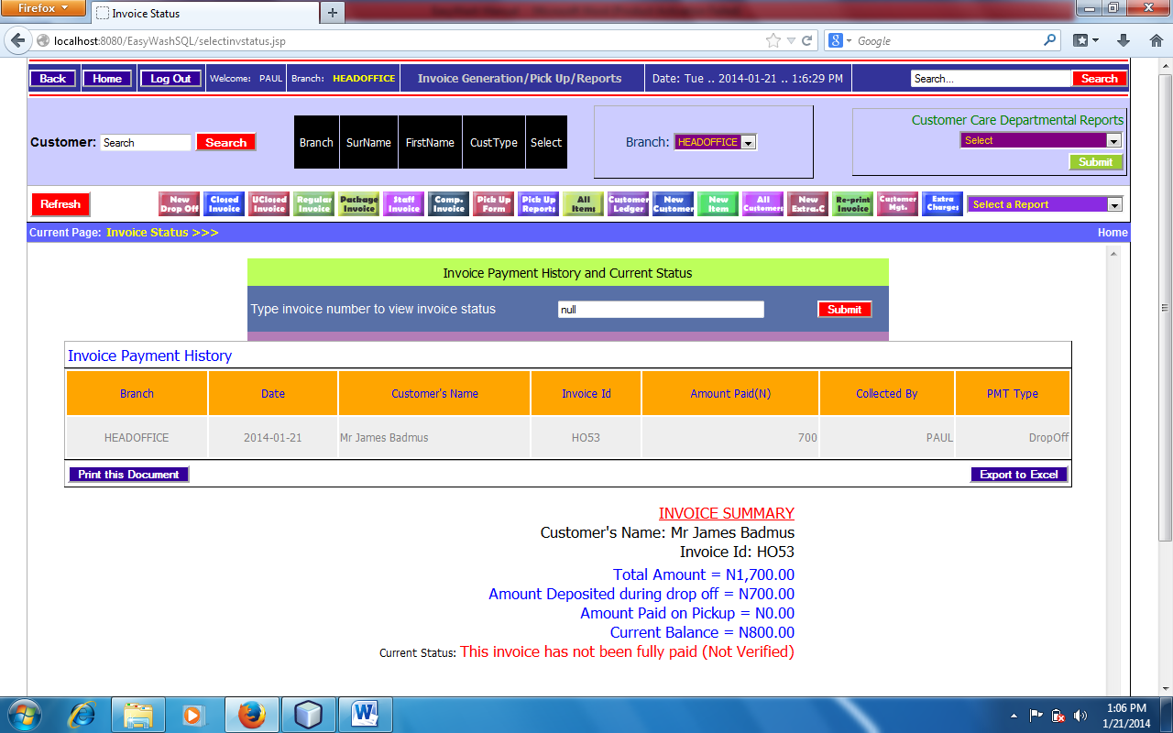

All Incoming Invoices
All Incoming Invoices is a record showing all the invoices(Regular, Package, staff and Complementary invoices) as a single report and also calculate the total sales made in a particular period.
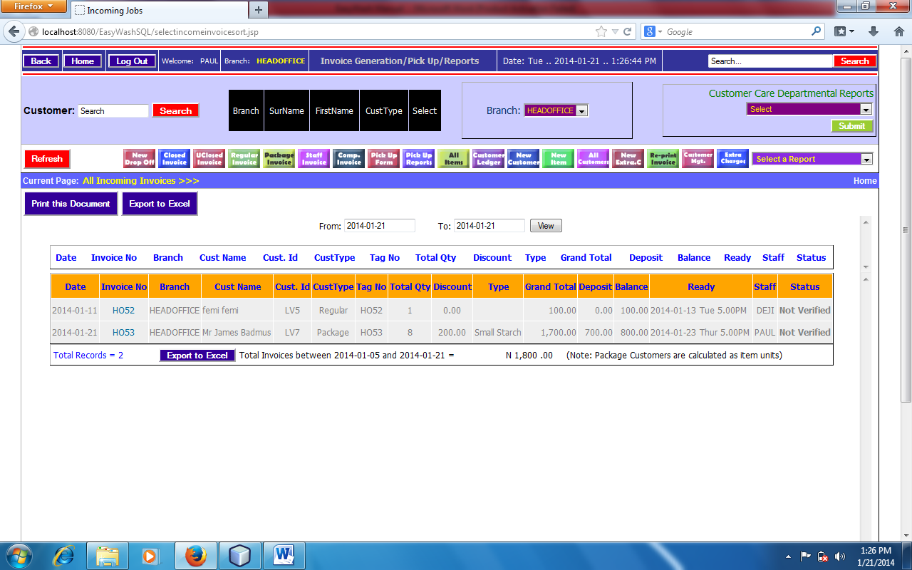
To view all incoming invoices:
- Click on the Select menu
- Click on View all Incoming Invoice. This will display all invoice (Regular, Package, Staff and Complementary) in one place even with the total of the invoices. You can also sort from this end.
Package Customers
Package customers are the type of customer that pays upfront for a particular number of pieces. They are regarded as a special customer.

How to order for package account:
- Firstly the person must be registered as a package customer in the customer registration form. A customer can have both regular and package account on the system.
- Open customer’s information using the short cut button in the customer service module. Click on all customer. For fast and better result, use search button to search for the customer as shown below.

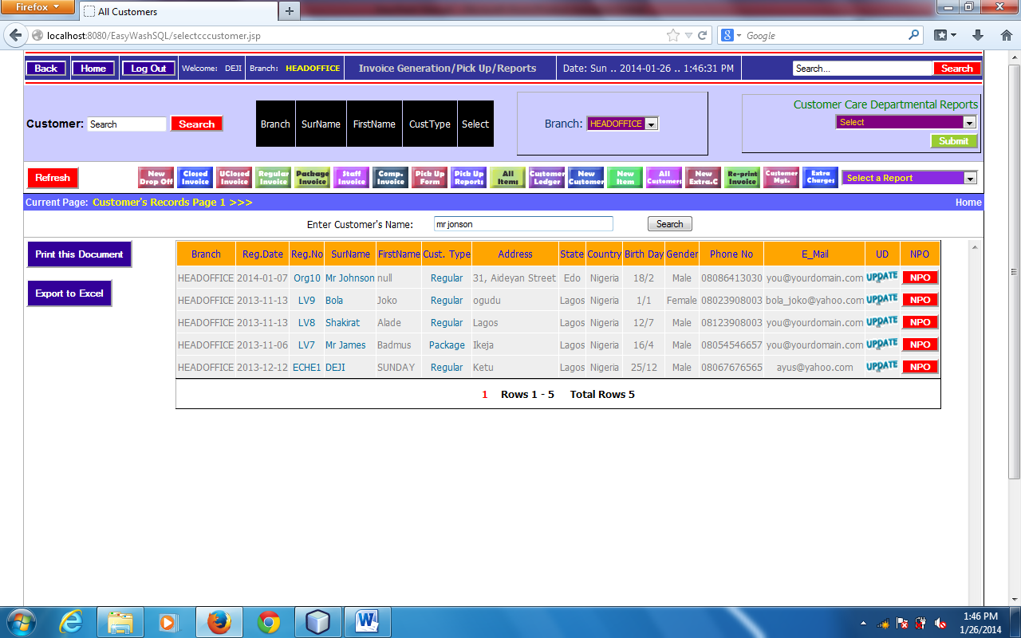
- Click on NPO(New Package Order). This will take you to New Package Order Form where u fill all necessary information including total number of pieces you (Customer) want to order for as shown below.

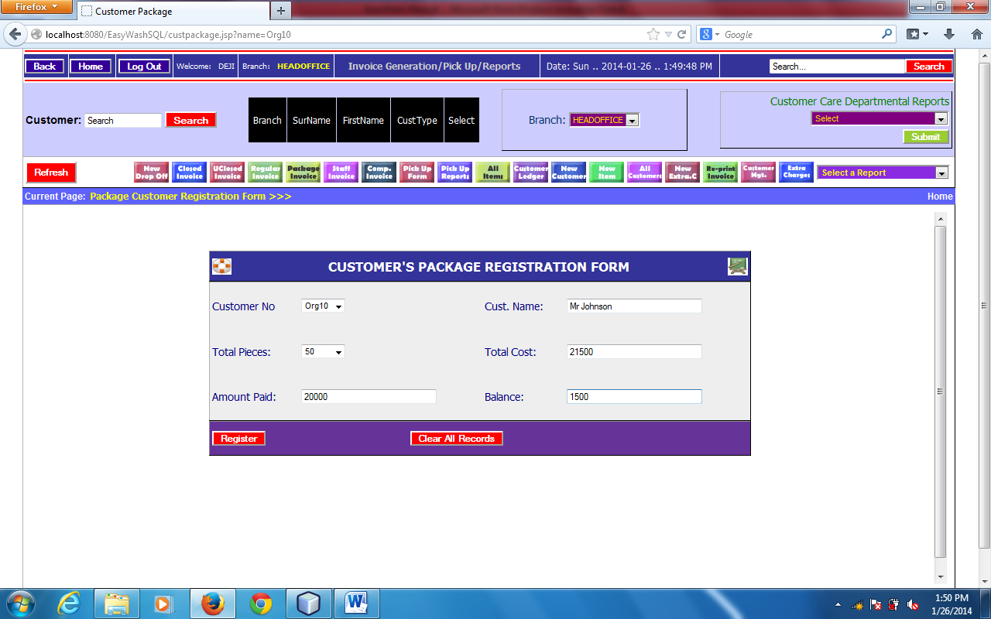
The above picture shows customer’s package order form with customer’s registration number, customer’s name, total pieces of the items applied for, total cost, amount paid and balance to be paid later.
- Click on register to finish the registration. This will take you to package customers report where you will find all registered package customer with order information and garment balance including the balance to be paid.

To view all Package Customers:
- Click on Select a report combo box in the customer’s Service module
- Click on View All Package Customers. You can click on payment history to view customer’s payment history for his/her package order. Also click on update button pay for previous balance or order for a new package. The picture below shows all package customers

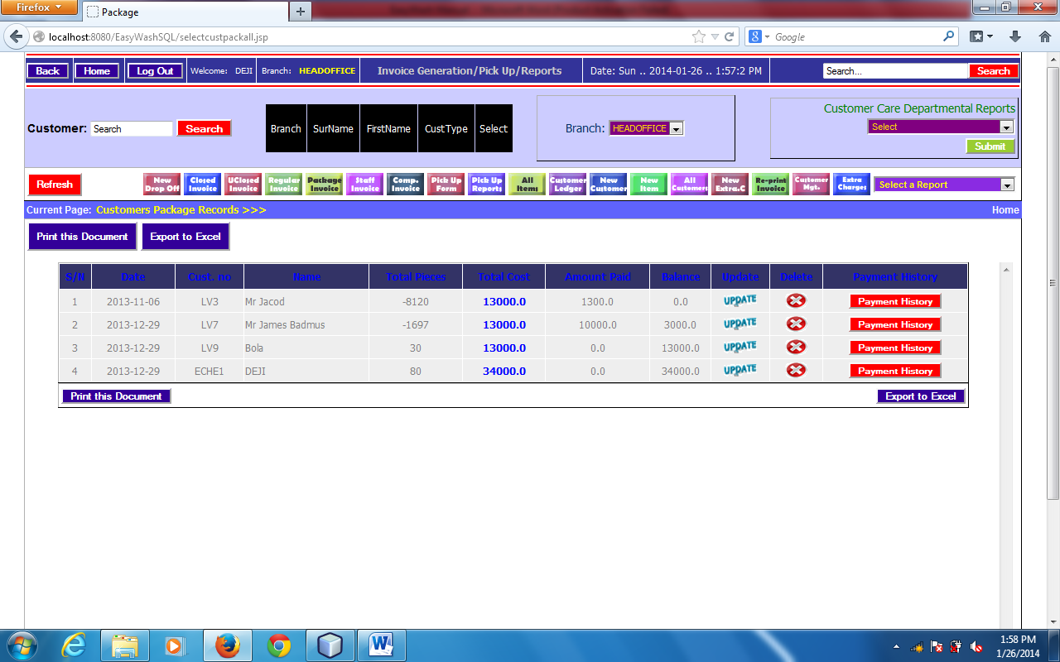

How to generate invoice for package customer:
Generating invoice for package customers is the same as generating for regular and other customers. The major difference is the item drop phase where you need to click on package from the buttons below the cloth icons. This will allow system to display the number of package pieces for the item. At times the number of pieces of the item is the same as the number of package unit. Each time you want to drop an item, you need to click on package button to change the normal price to package unit before dropping the item. Always check the garment balance before dropping items for package customers

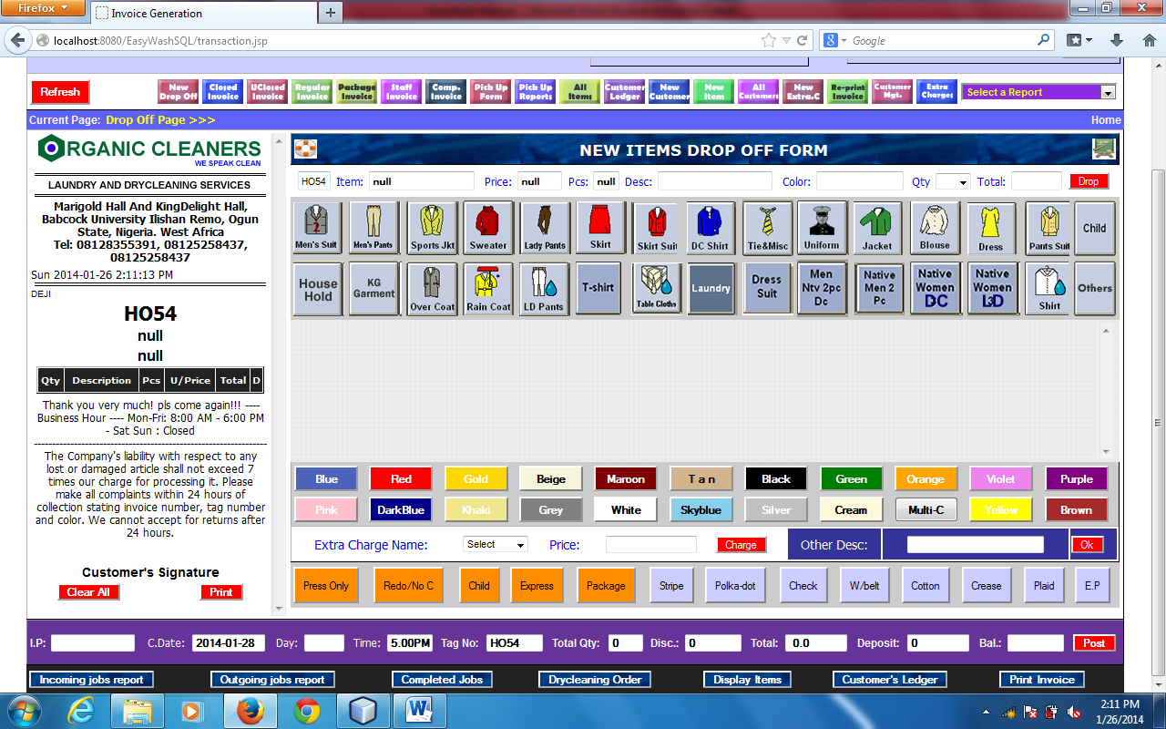

Customer Relationship Management (CRM):
CRM is the abbreviation for customer relationship management. It entails all aspects of interaction that a company has with its customer, whether it is sales or service-related. While the phrase customer relationship management is most commonly used to describe a business-customer relationship, CRM systems are used in the same way to manage business contacts, clients, contract wins and sales leads.
CRM is often thought of as a business strategy that enables businesses to:
- Understand the customer
Retain customers through better customer experience
Attract new customer
Win new clients and contracts
Increase profitably
Decrease customer management costs
EasyWash.ERP application provides exceptional Customer Relationship Management System that enables users to get transaction details and personal information about customers. It enables to know how often customers are patronizing the company and best customer at a particular time. It helps to know the birth day of the customer and sent relevant messages to them.
Customer relationship management solutions provide you with the customer business data to help you provide services or products that your customers want, provide better customer service, cross-sell and up sell more effectively, close deals, retain current customers and better understand who your customer are.
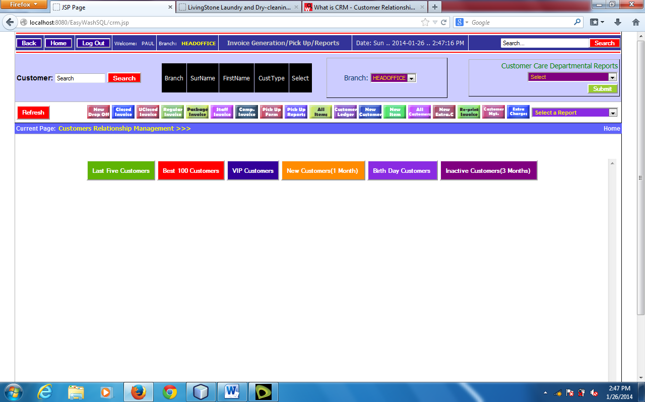
To view CRM:
- Click on Customer Management from the short cut buttons

Extra Charge
Extra charge is the up charge for a particular service. Extra charge can be added for an item before drop off. Some cloth item may require special treatment which may need additional charge. There is no particular amount for extra charge; it depends on the type of treatment for the cloth items.
To add extra charge for an item:
- Select Extra Charge from combo box below the Color button
- Select the type of Extra Charge that you want
- Click on charge button. You will see the extra charge amount added to the regular price of the item
- Now you can Drop the item
Remember that you must register the entire Extra Charge item before you can up charge.
To Register New Extra Charge:
- Click on New Extra C. from the Short Cut buttons
- Enter all the necessary fields
- Click on register.
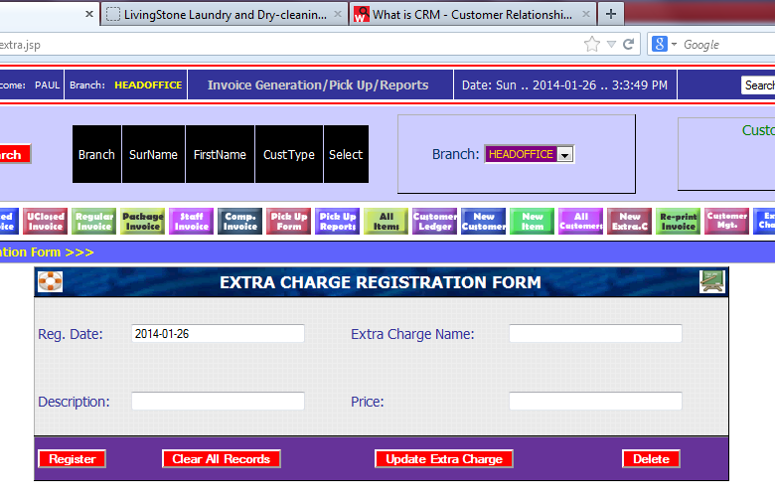

Note that Extra Charge cannot be done manually since the price cannot altered by customer service officers.

Void/Delete invoice
An invoice can be voided or deleted if there is a mistake during generating invoice or a controversial invoice. A customer service officer will report to the administrator and explain why invoice should be voided or deleted. The administrator can login to his or her Admin area to void the invoice by entering the invoice number.
Note that all money posted to the accounting module will be deducted once the invoice is voided or deleted

Void Receipt
The same as void invoice

Express Invoice
Express invoice is the urgent invoice that is needed same day which will attract extra payment for the inconveniency for the company. Generating Express invoice is synonymous to the package invoiced. An Express button is available to be clicked once an item is express. 50% of the original cost will be added to price for express item/invoice. For instance, if the original cost is N600, the Express cost will be N900.
It is advisable to generate separate invoice for Express invoice in order to attract especial attention in the operation department

Redo/No charge
This occurs if there is a mistake during cloth processing in the operation department. The items may be re-processed without attracting any charge.
Click on Redo/No Charge button before dropping the item to change the item price to 0
Invoice Preference (I.P.)
This is the special message that will appear boldly on the invoice for processing purposes. The type of message maybe Little Starch, Folded or Hanged, Express, Redo/No charge. Endeavour to use very short description.
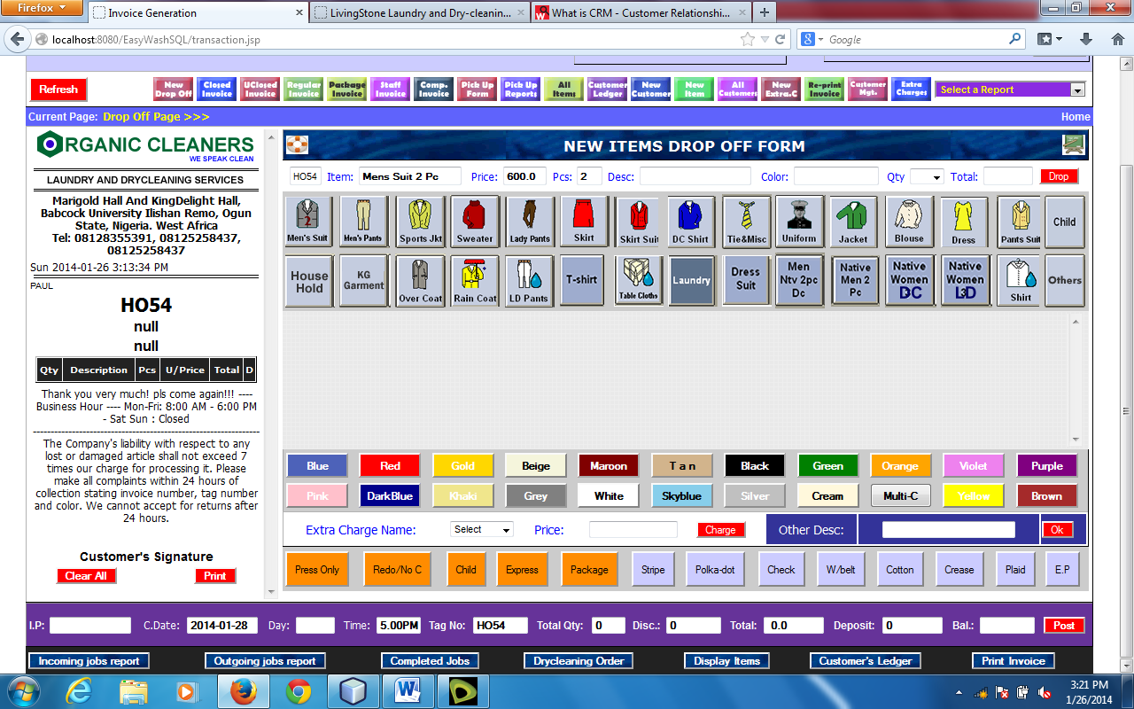

ACCOUNTING / ADMIN / HUMAN RESOURCES
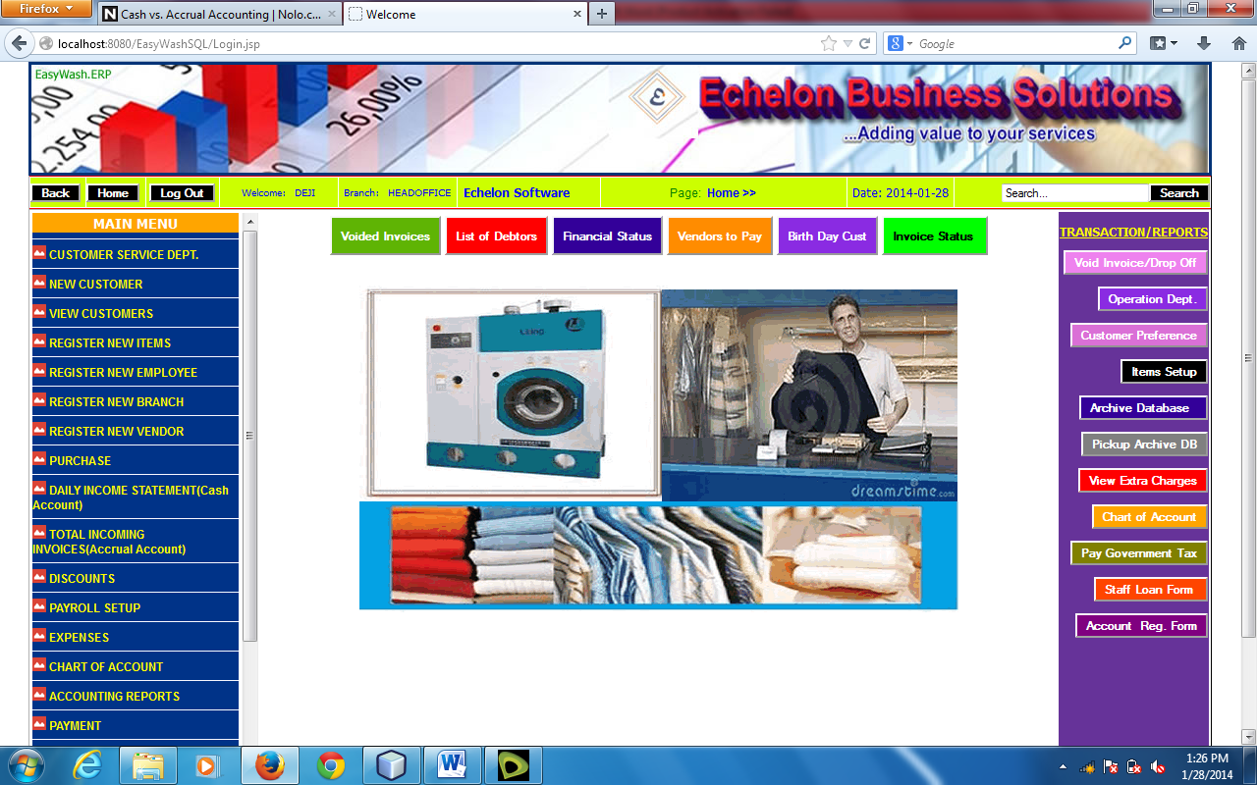
This module covers Accounting Systems of the organization, Administrative activities and Human Resources. The Accounting System prepares every aspect of accounting in the organization customized to suit Laundry and Drycleaning Services. The accounting module prepares two types of Accounting Methods:
- Cash Accounting
- Accrual Accounting
Cash AccountingVs Accrual Accounting:
The Cash method of accounting, Cash receipts and disbursements method of accounting or Cash accounting records revenue when cash is received, and expenses when they are paid in cash, in contrast to the alternative accrual method which records income items when they are earned and records deductions when expenses are incurred regardless of the flow of cash.
The cash method and the accrual method (sometimes called cash basis and accrual basis) are the two principal methods of keeping track of a business's income and expenses. In most cases, you can choose which method to use. Learn how they work and the advantages and disadvantages of each so you can choose the better one for your business.
In a nutshell, these methods differ only in the timing of when transactions, including sales and purchases, are credited or debited to your accounts. Here's how each works:
The cash method: The cash method is the more commonly used method of accounting in small business. Under the cash method, income is not counted until cash (or a check) is actually received, and expenses are not counted until they are actually paid.

Example 1
Your Laundry and Drycleaning business finishes a job in November, and doesn't get paid until three days later in January. Under the cash method, you would record the payment in three days later. Under the accrual method, you would record the income in your daily books.

Example 2
You purchase a new Chemical that you are using to remove stains on credit in May and pay N1,000 for it in July, two months later. Using the cash method, you would record a N1,000 payment for the month of July, the month when the money is actually paid. Under the accrual method, you would record the N1, 000 payment in May, when you take the Chemical and become obligated to pay for it.
The accrual method: Under the accrual method, transactions are counted when the order is made, the item is delivered, or the services occur, regardless of when the money for them (receivables) is actually received or paid. In other words, income is counted when the sale occurs, and expenses are counted when you receive the goods or services. You don't have to wait until you see the money, or actually pay money out of your checking account, to record a transaction.
EasyWash.ERP Laundry and Drycleaning Management Application provide the two accounting methods that make your laundry business more accountable.
The Accounting module also manages stocks available in the store, purchase history and Issuing report of the stock.
It can prepare Balance Sheet, Profit and Loss Account, Bank Statements, and Fixed Asset etc.
The Admin module can verify invoice before it is finally closed, Update invoice by changing name of the customer (But not advisable), Edit comment on the invoice, change address and phone numbers, Register new employee and other administrative work.
Human Resources module will setup payroll for customers, manage staff’s information and prepare payroll for staffs.
TABLE OF CONTENTS FOR ACCOUNTING/ADMIN/HR
- User Login
- Welcome page/Home page for Admin/Accounting/HR
- Chart of Account
- Beginning Balances
- Fixed Asset
- Paid-in-Capital(Equity Account)
- Raw Materials(Consumables)
- Inventory
- New Employee
- Activate and Deactivate Employee
- Payroll setup
- New customer
- New Vendors
- Purchase
- Expenses
- Daily income report(Cash and Accrual)
- Journal entry
- Discounts
- Verify invoice
- Update price items
- Edit phone number and comment
- Void Invoice and Receipt
- Taxation
- Bank Deposit
- Bank Withdrawal/Cheque
- Accounting Reports:
- Cash Book
- Account Payable
- Account Receivable
- Income Statement
- Profit and Loss Account
- Balance Sheet
- Fixed asset Report
- Chart of Account
- Expenses
- Inventory
- Payment Records
- Payroll Reports
- Bank Deposit Records
- Withdrawal Records
- Bank Statement
User Login
This is the area where a user enters his or her Admin username and password.
To login to the Admin department, launch the application with your domain name e.g. www.easywasherp.com.

In the home page select Head Office and enter your username and password, click on login button. If login successful, Admin/Accounting/HR module will be launched.

Welcome page/Home page for Admin/Accounting/HR
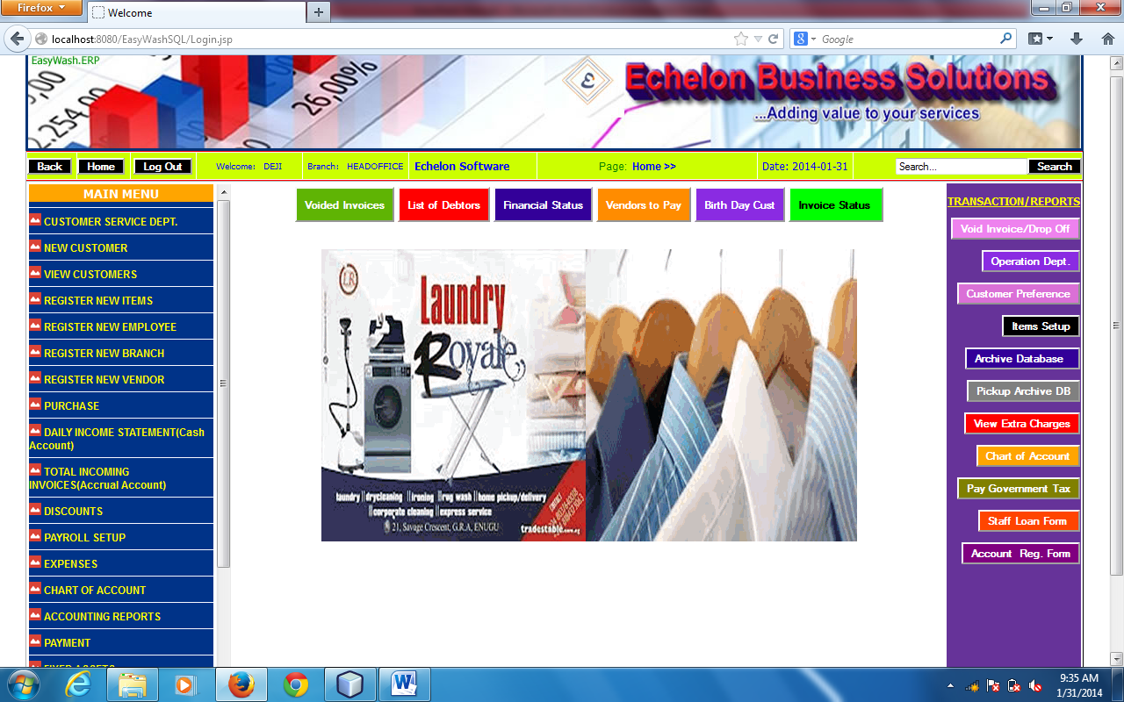
Admin and Accounting module is a page where you do all the accounting and administrative activities. You can view the cash received today and sort it with several option, view all incoming invoice per day with total without going to Customer Service page. With your Admin Password, you can check payment history for a particular invoice and verify the invoice before it is finally closed and other Accounting activities.

Chart of Account
Your company’s chart of account is nothing more than a list of places to enter transactions that will be recorded in the General Ledger. It contains an identifying code (the Account ID—usually a number), a description (the account name), and a type code. Accounts are used to classify transaction information for reporting purposes.
Chart of Account can vary depending on the business type. Echelon Accounting allows you a great deal of flexibility in designing your own Chart of Account. However, you can probably save a great deal of time by use the sample chart during New Company Setup and modifying it to meet your specific business needs.
Consult your accountant when setting up your chart of accounts. There are special things you can do during the setup phase that will make your financial statements more useful.
To Setup New Chart of Account
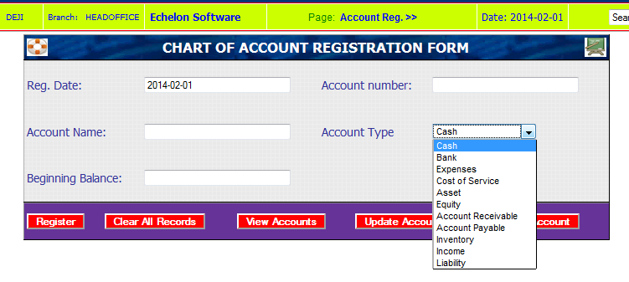
- Click on Chart of Account from the Menus
- This will display New Chart of Account form as shown in the above diagram
- Enter Account Id, Account Name, Select Account type from the list and enter beginning balances
- Click on register button

Beginning Balances
During account setup, you will need to enter beginning balance for some account that you setup. For instance, startup capital will debit Equity Account or Paid-in-Capital. The same money will be transferred using journal entry to cash at hand or cash at bank or inventory account if it has been disburse for raw material for fixed asset.
Fixed Asset
These represent property, plant or equipment assets that are acquired for use in a business rather than for re-sale. These are called fixed assets because they are to be used for long period of time.
You need to select Fixed AssetAccount Type if you are setting up the following account:
- Land: property, storage space, or parking lots.
- Buildings: structures in which the business is carried out.
- Machinery: heavy equipment used to carry out business operations. For example, you may want to set up any of the following: store equipment or fixtures, factory equipment or fixtures, office equipment or fixtures (including computers and furniture), and delivery equipment (including autos, trucks, and vans used primarily in making deliveries to customers).

To register Fixed Assets
- Click on Fixed Assets from the Menus in the Admin module. A page will display showing the Fixed Assets Form as Shown below:
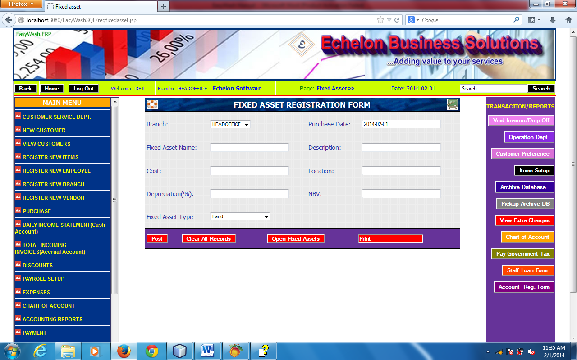
- Enter the necessary fields including depreciation, present cost and fixed asset type
Note that, the cost is not the actual amount of money that you purchase the machine if it is not a new one. Enter the present value of the machine as the cost.
- Click on post to register fixed asset

Paid-in-Capital(Equity Account)
Equity, also known as capital or net worth, is the amount owners have invested in a business. In the equity section of your chart of accounts, you must do three things:
- show the initial investment (Paid-in-Capital), Owner's Contributions)
- track withdrawals from this investment (Owner's Draw, DividendPaid )
- show the combined profit or loss of the business since inception (Retained Earnings)
Equity can also be thought of as the owner's claims against the assets (versus the claims of others, which are liabilities). Equity will always equal what is owned (assets) minus what is owed (liabilities).

EQUITY = ASSETS - LIABILITIES

Inventory
This represents the quantity (value) of goods on hand and available for sale at any given time. Inventory is considered to be an asset that is purchased, manufactured (or assembled), and sold to customers for revenue.
Select this account type if you are setting up assets that are intended for resale. It is common practice to create different accounts for each category of inventory that you want to track (for example, retail inventory, raw material inventory, work in progress inventory, finished goods inventory, and so on).

These are items used for

- Inventory
- New Employee
- Activate and Deactivate Employee
- Payroll setup

